**Step-by-Step Guide to Install Raspberry Pi OS on a Raspberry Pi Single Board Computer!**

[Raspberry Pi OS](https://thesecmaster.com/step-by-step-guide-to-install-raspberry-pi-os-on-a-raspberry-pi-single-board-computer/) is a Debian-based operating system developed by Raspberry Pi Foundations. It is the operating system that is specifically designed for the Raspberry Pi Single Board Computer board. And it s an excellent choice for anyone looking to start using and exploring the possibilities of DIY computing using Raspberry Pi boards. The operating system provides outstanding flexibility with respect to its hardware compatibility, allowing it to be used with a wide range of Raspberry Pi models. Additionally, the operating system is open source and free, providing users with access to its source code which can be edited and improved by anyone with advanced knowledge. [Raspberry Pi OS](https://thesecmaster.com/blog/install-raspberry-pi-os-on-vmware-workstation) carries many advantages over other operating systems when it comes to running Raspberry Pi. All these made Installing [Raspberry Pi OS](https://thesecmaster.com/step-by-step-guide-to-install-raspberry-pi-os-on-a-raspberry-pi-single-board-computer/) on a Raspberry Pi Single Board Computer an excellent choice for everyone.

If you’re looking for a step-by-step guide to installing [Raspberry Pi OS](https://thesecmaster.com/step-by-step-guide-to-install-raspberry-pi-os-on-a-raspberry-pi-single-board-computer/) on a Raspberry Pi Single Board Computer, then you are at the right place! In this blog post, I’ll walk you through the entire process of running [Raspberry Pi OS](https://thesecmaster.com/blog/install-raspberry-pi-os-on-vmware-workstation) on a Raspberry Pi board. I’ll also provide tips and tricks to help you get the most out of your Raspberry Pi on this website. So, let’s get started!‍

## Introduction to Raspberry Pi 4 Mod B

Raspberry Pi is a small single-board computer developed by the [Raspberry Pi Foundation](https://www.raspberrypi.org/) in the United Kingdom. It is a credit card-sized computer that is powerful enough to be used as a desktop computer or to control robots, build projects, and much more. The Raspberry Pi is powered by an ARM processor, which means it is capable of running a variety of operating systems.

We have chosen Raspberry Pi mod 4B board to install Raspberry Pi OS as it is powered by a Broadcom BCM2711 quad-core Cortex-A72 processor and comes with 1GB, 2GB, 4GB, or 8 RAM of RAM variants. It also has a Gigabit Ethernet port, two USB 3.0 ports, two USB 2.0 ports, and a 4-pole stereo output and composite video port. All this hardware makes it used as a general-purpose computer, and it is ideal for projects such as building a [file server](https://thesecmaster.com/the-ultimate-guide-to-build-a-personal-cross-platform-file-server-on-raspberry-pi/), [media center](https://thesecmaster.com/build-your-own-ott-platforms-like-netflix-using-raspberry-pi-and-plex-media-server/), making a home automation system, or setting up a [home surveillance system](https://thesecmaster.com/step-by-step-procedure-to-build-your-own-surveillance-system-using-raspberry-pi/).

The Raspberry Pi 4 is also ideal for running a variety of operating systems like Ubuntu, Debian, [Mint Linux](https://thesecmaster.com/step-by-step-procedure-to-install-linux-mint-linux-on-vmware-workstation/), [Kali Linux](https://thesecmaster.com/install-kali-linux-on-vmware-workstation/), Manjaro, and Windows 10, and the list is endless. Since it has enough processing power and memory to run the Linux distribution, it is a great choice for running many DIY projects. It is also relatively inexpensive and easy to set up, making it an attractive option for users who want to explore the world of digital forensics and penetration testing.

## The New Raspberry Pi 5 and Raspberry Pi Imager 1.8x

**Update**: The Raspberry Pi Foundation released the new [Raspberry Pi 5](https://thesecmaster.com/the-brand-new-raspberry-pi-5-is-here-lets-see-what-is-new-in-raspberry-pi-5/) on October 2023. With upgraded hardware and computational resources. The Raspberry Pi 5 represents the biggest upgrade ever to the Raspberry Pi family of [single board computers](https://thesecmaster.com/what-are-single-board-computers-sbcs-and-why-you-should-buy-single-board-computers/). It packs in a faster 64-bit quad-core Arm processor running at 2.4GHz, an upgraded VideoCore VII GPU, support for dual 4K displays via HDMI 2.0, advanced camera interfaces, high-speed storage, and connectivity options like USB 3.0 and Gigabit Ethernet with PoE capability.

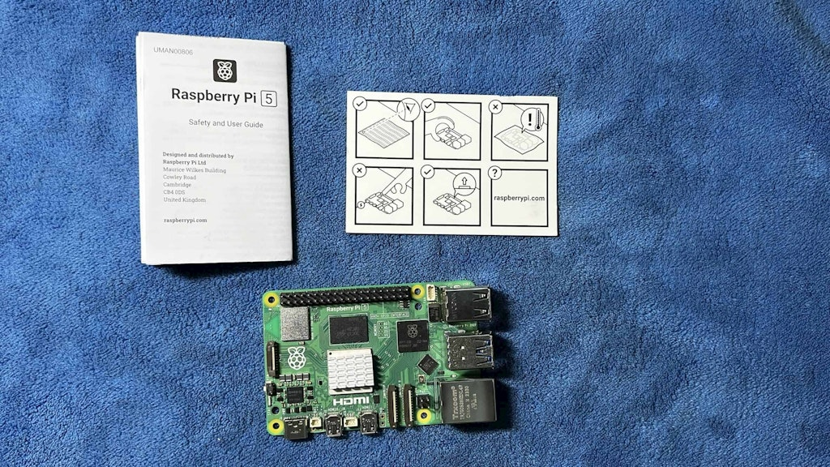

Here are the key hardware specifications of the Raspberry Pi 5:

* **Processor**: Broadcom BCM2712 – 2.4GHz quad-core 64-bit Arm Cortex-A76 CPU, 512KB L2 cache per core, 2MB shared L3 cache
* **GPU**: VideoCore VII GPU, supporting OpenGL ES 3.1, Vulkan 1.2
* **Memory**: 4GB or 8GB LPDDR4X SDRAM
* **Display**: Dual micro HDMI 2.0 ports supporting up to 4Kp60 resolution
* **Video Decode**: H.265 (4Kp60), H.264 (1080p60 decode, 1080p30 encode)
* **Camera**: Dual 4-lane MIPI CSI camera interfaces
* **Wireless**: 802.11ac dual-band WiFi, Bluetooth 5.0
* **Ethernet**: Gigabit Ethernet with PoE capability
* **USB**: 2x USB 3.0 ports, 2x USB 2.0 ports
* **Storage**: MicroSD card slot with support for SDR104 high-speed mode
* **Audio**: HDMI, 3.5mm stereo jack
* **GPIO**: 40-pin header compatible with HAT add-ons
* **Other I/O**: PCIe 2.0, 2x MIPI DSI display interfaces, real-time clock, power button

### Raspberry Pi Imager 1.8x

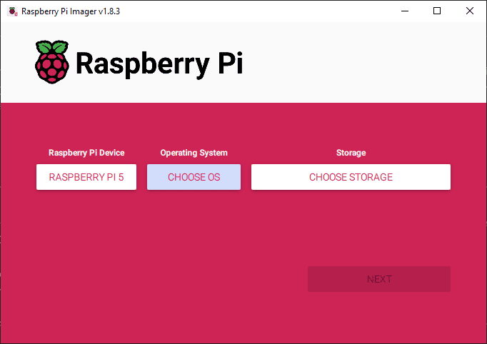

Now, you know about the new Raspberry Pi 5 computer. At the same time, the Raspberry Pi Foundation released its new Imager application: [Raspberry Pi Imager 1.8x](https://thesecmaster.com/what-are-the-new-features-added-to-raspberry-pi-imager-1-8-1-and-above/).

Here are the main key changes seen in the new Raspberry Pi Imager 1.8x.

The key changes introduced in the new Raspberry Pi Imager (version 1.8.1 and above) are as follows:

1. New Home Screen for Selecting Raspberry Pi Model:
   * The introduction of a home screen that prompts users to select their specific Raspberry Pi model before choosing the OS image. This helps filter the OS list to display only compatible distributions for the selected device, preventing accidental flashing of unsupported OS versions.
2. OS Customization Gets New Tabbed Interface:
   * The “Advanced Options” section for configuring OS parameters has been renamed to “OS Customization” in the latest release.
   * The OS Customization section now uses a tabbed UI structure, making it easier for users to navigate and configure various settings related to hostname, username, password, WiFi country, locale, enabling SSH, and specifying the public key for auto-login.
3. Enhanced Progress Reporting and Status Updates:
   * Improved progress indicators that parse uncompressed size metadata of .xz compressed image files, providing more accurate progress bar updates during the flashing process.
   * Sound effects play after completing the writing process, confirming the status, reducing the need for continuous monitoring.
4. Other Handy Improvements:
   * Drag-and-drop support for Raspberry Pi image files, allowing users to directly drag and drop files onto the Imager window for flashing.
   * Multi-language support with added Spanish and Ukrainian localizations and updates to existing translations.
   * Keyboard navigation fixes to improve accessibility.
   * Compatibility with Raspberry Pi 5 hardware for easy migration.
   * Implementation of a workaround for Arch Linux’s internal card reader detection issue, addressing SD card flashing challenges faced by Arch Linux Pi users.

These changes enhance the user experience, especially for newcomers to Raspberry Pi, by simplifying the OS selection process, improving customization options, and providing better progress feedback during image flashing.

## What is Raspberry Pi OS?

Raspberry Pi OS is a Debian-based operating system specifically designed for the Raspberry Pi Single Board Computer, which was developed by the [Raspberry Pi Foundation](https://www.raspberrypi.org/) in the United Kingdom. It is an open-source software project, meaning that it is free to use, and anyone can modify its source code with the proper knowledge. [Raspberry Pi OS](https://thesecmaster.com/step-by-step-guide-to-install-raspberry-pi-os-on-a-raspberry-pi-single-board-computer/) comes with a wide range of functionalities built in, such as support for GPIO pins, video output, and audio output. It is a Linux-based operating system that offers users access to the extensive library of applications available within its repositories. The operating system can also be configured to run specific tasks such as media streaming, home automation, and robotics via the open-source software libraries provided by [Raspberry Pi OS](https://thesecmaster.com/step-by-step-guide-to-install-raspberry-pi-os-on-a-raspberry-pi-single-board-computer/). With its flexibility and ease of use, Raspberry Pi OS is an ideal choice for those looking to get started with the Raspberry Pi.

## Why Should You Install Raspberry Pi OS on a Raspberry Pi Single Board Computer?

Installing Raspberry Pi OS on a Raspberry Pi 4 has many benefits.

1. Compatibility: Raspberry Pi OS is designed to be compatible with most Raspberry Pi 4 models, offering users the best possible performance on their devices.

2. Flexibility: With access to its source code, users can customize and configure the operating system as it fits their project needs and interests.

3. Open-source software library: The board comes with a wide range of software packages that can be easily installed and used on the device.

4. Performance: [Raspberry Pi OS](https://thesecmaster.com/step-by-step-guide-to-install-raspberry-pi-os-on-a-raspberry-pi-single-board-computer/) offers optimal performance, allowing users to enjoy their multimedia experience without issues such as lag or stuttering.

5. User-friendly interface: The operating system’s user interface is easy to navigate, making it ideal for both beginners and experienced users.

6. Cost-effective: As Raspberry Pi OS is free to use, users don’t need to invest in expensive software packages or licenses for their projects.

7. Security: The operating system offers a secure environment that can be used for sensitive tasks such as banking without the risk of data breaches.

8. Variety: Raspberry Pi OS supports a wide range of applications and projects, from media streaming to robotics and automation.

Raspberry Pi OS is an excellent choice for anyone looking to get started with the Raspberry Pi 4 Single Board Computer. With its compatibility, flexibility, performance, user-friendly interface, cost-effectiveness, security, and a large variety of applications available in its library, it is the perfect operating system for any DIY computing project. Install Raspberry Pi OS on a Raspberry Pi 4 to get the most out of your device and explore the world of DIY technology!

## What Are the Prerequisites for Installing Raspberry Pi OS on A Raspberry Pi 4?

Before you install Raspberry Pi OS on your [Raspberry Pi](https://thesecmaster.com/how-set-up-a-raspberry-pi-for-the-first-time/) 4, you need to make sure that you have all of the necessary components. First and foremost, you will need a Raspberry Pi 4, which is available in 1GB, 2GB, 4GB, and 8GB RAM variants. You will also need a power supply and a microSD card with at least 8GB of storage capacity or USB storage with the same storage requirements. Additionally, you will need a micro HDMI cable, a USB keyboard and mouse, and a compatible monitor.

##### Hardware:

1. [Raspberry Pi Board](https://amzn.to/3R5SnYy): Well, you can use any Raspberry Pi module 4, or 400. Preferably, Raspberry Pi 3 and 4 with 4 GB RAM.
2. [Micro SD Card](https://amzn.to/3t3yVU9) with Card Reader: This is to write the Raspberry Pi OS image.
3. [USB Drive](https://amzn.to/47D5I1B) (Optional): This is to install Ubuntu. It is optional. This is required only if you boot your Pi from USB storage.
4. IO Peripheral Devices: [Keyboard, Mouse](https://amzn.to/3sSIs0t), [HDMI Cable](https://amzn.to/3t4mMys), [Ethernet Cable](https://amzn.to/3uGnq5v), and [USB Cable](https://amzn.to/46GiDOY), depending on your requirements.
5. PC or Mac with an Internet connection: This is required to download the [Raspberry Pi Imager application](https://www.raspberrypi.com/software/) and write the Raspberry Pi OS image to the SD Card or USB Storage Drive using the Imager application.

##### Software:

1. Raspberry imager: A free utility released by [Raspberry Pi Imager application](https://www.raspberrypi.com/software/) for flashing content to SD cards or USB drives.
2. Internet: An [Internet connection](https://amzn.to/47DPCVb)is a must to have to download the Raspberry Pi Imager and write the Raspberry Pi OS to the SD Card or USB Storage Drive.

Once you have all of the necessary components, you can start the process of installing Raspberry Pi OS on your Raspberry Pi 4.

## How to Install Raspberry Pi OS on A Raspberry Pi 4?

Installing Raspberry Pi OS on a [Raspberry Pi](https://thesecmaster.com/how-set-up-a-raspberry-pi-for-the-first-time/) 4 is a relatively straightforward process. Well, you can install Raspberry Pi OS on a Raspberry Pi in two different ways.

1. Write the bootable Raspberry Pi OS image to the micro SD card or the USB drive directly using the Raspberry Pi imager application.
2. Download the bootable ISO image of Raspberry Pi OS from the official Raspberry Pi [website](https://www.raspberrypi.com/software/operating-systems/)and write using the Raspberry Pi imager or [Etcher](https://etcherofficial.com/)application to the micro SD card or the USB drive.

Both are relatively simple. There is no problem in following either way. We will look into both ways in this post. However, we have covered the 1st method extensively in this post since we believe it is the most recommended one for beginners.

### Method 1: Flash the raspberry Pi Image to the micro SD or USB drive directly from the Raspberry Pi Imager

Download the [Raspberry Pi](https://thesecmaster.com/how-set-up-a-raspberry-pi-for-the-first-time/) Imager application on your Windows PC or mac book. Just follow the on-screen instructions, and the installation process should be completed in a few minutes. Once the installation is complete, you can start exploring the features of the Raspberry Pi Imager application.

Time needed: 30 minutes.

**How to Install Raspberry Pi OS on A Raspberry Pi 4?**

1. **Download and Install the Raspberry Pi Imager application**

Raspberry Pi Imager is a quick and easy way to install Raspberry Pi OS and other operating systems to a microSD card or USB drive. Watch this 45-second video to learn how to install an operating system using Raspberry Pi Imager.

1. the Raspberry Pi Imager application to a computer with an SD card reader. run the installer app and follow a few instructions to Install Raspberry Pi Imager. Put the SD card or USB drive you’ll use to install Raspberry Pi OS.

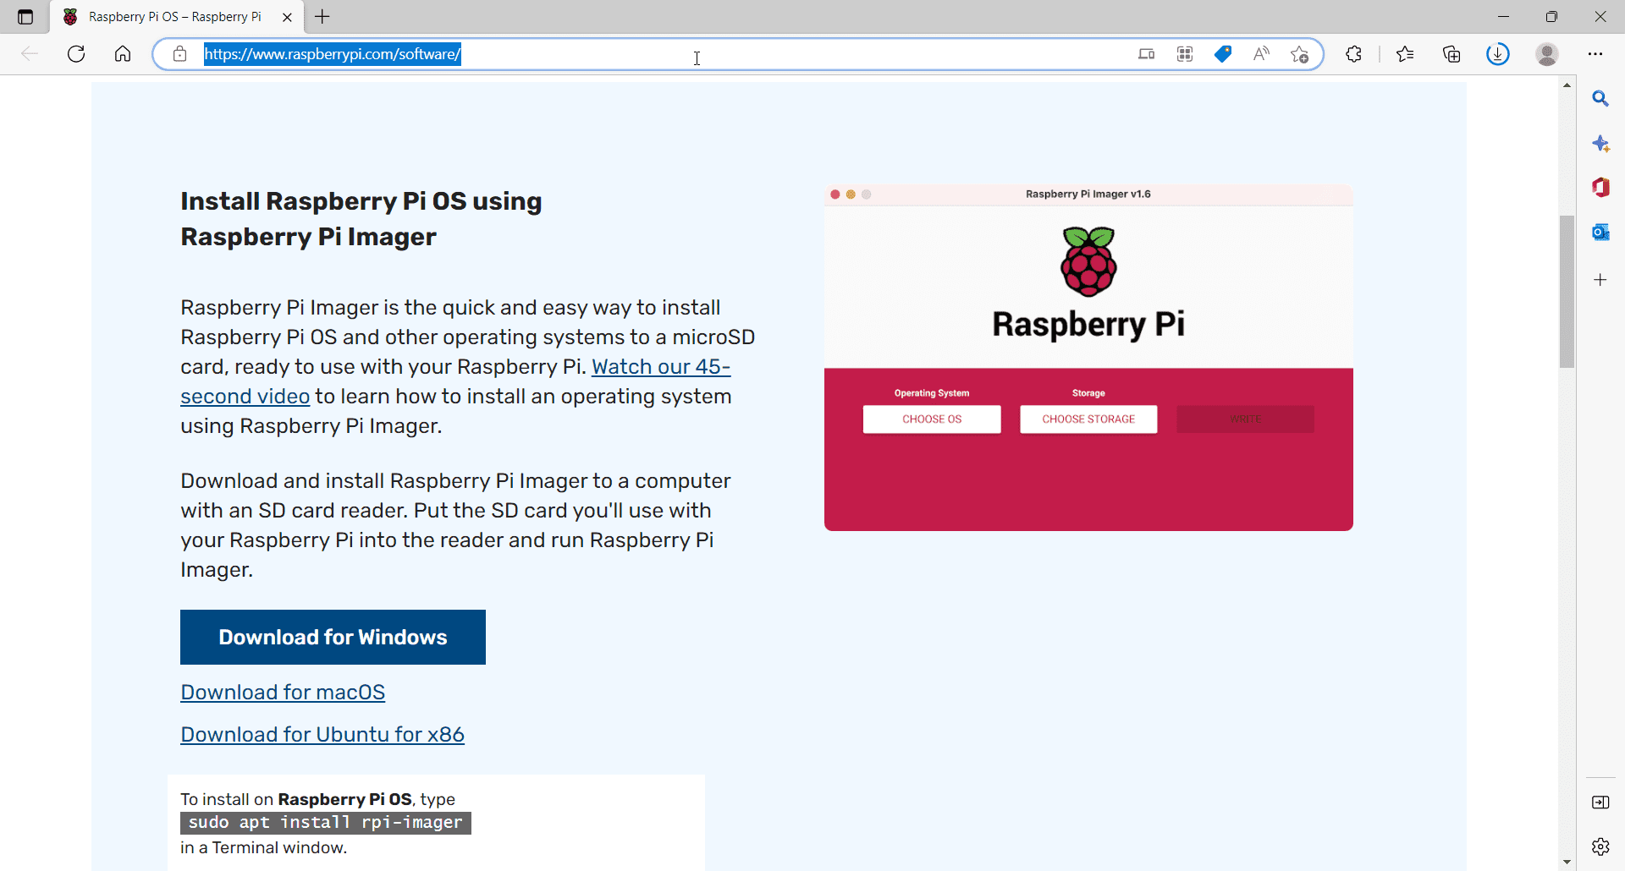

1. **Run the Raspberry Pi Imager application**

Upon installation, when you run the Imager application, you will be greeted with this window.

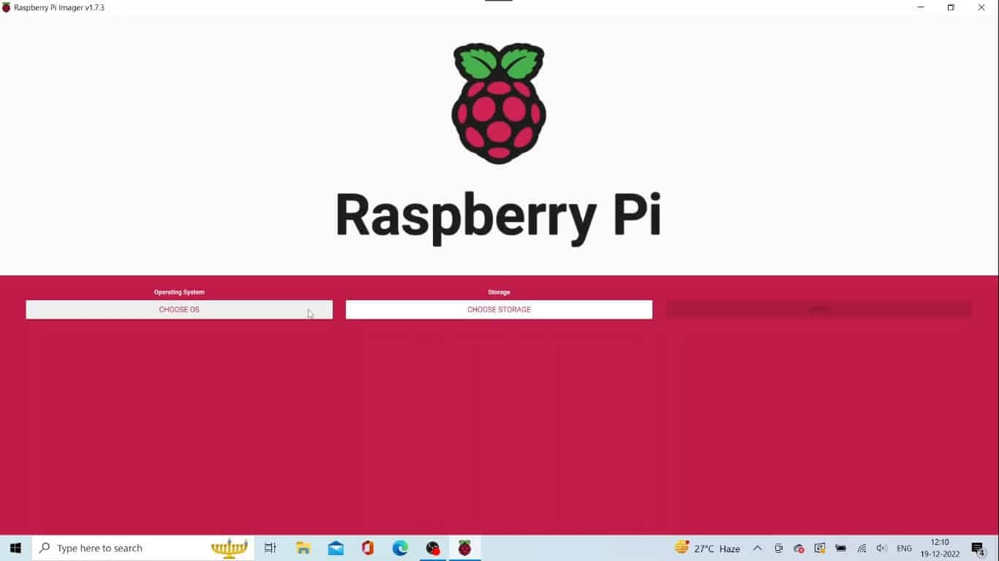

1. **Choose Raspberry Pi OS Image on the Raspberry Pi**

Click on the **Choose OS** button on the Imager application, select the **Raspberry Pi OS (Other)** option then click on Raspberry Pi OS variant you want. You will see a list of Raspberry Pi OS versions. Choose the one you want to go with.  
  
**Raspberry Pi Lite:** Raspberry Pi Lite is a version of the Raspberry Pi OS that only includes the essential components and features. It is designed to offer users support for their projects while reducing system resource usage, making it ideal for those who prioritize performance over features.  
  
**Raspberry Pi OS Full:**This version of the operating system includes all the features available with Raspberry Pi OS Lite along with the full range of applications and functionalities. It is especially suitable for those who want access to a wide variety of software packages, as it comes with an extensive library of open-source applications.  
  
**Raspberry Pi OS (Legacy):** This version was released alongside the original Raspberry Pi and is an outdated version of the operating system. As such, it is no longer supported by the Raspberry Pi Foundation and should only be used if absolutely necessary.

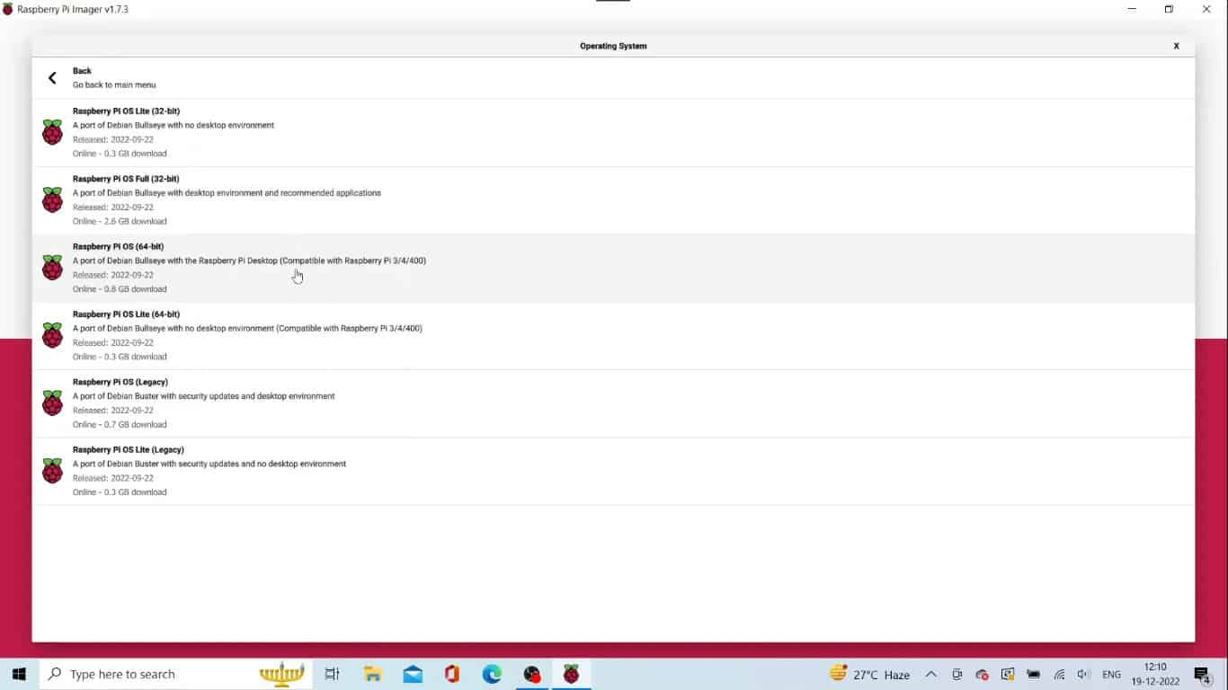

1. **Choose the Storage**

Click on the Choose Storage button on the Imager application. That will show up on the list of connected micros SD cards or USB storage devices. Select the one you want to install Raspberry Pi OS.

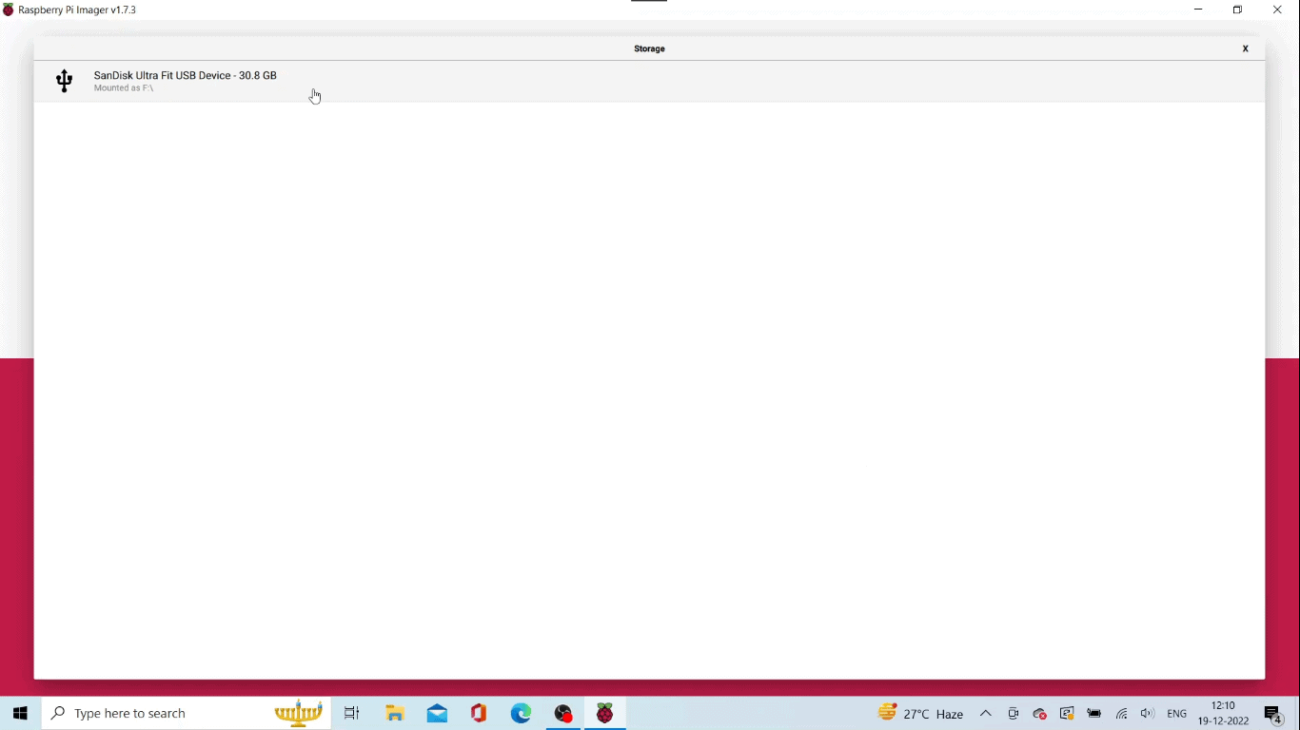

1. **Write the Raspberry Pi OS image to the storage**

Click on the Write button to start the writing process.

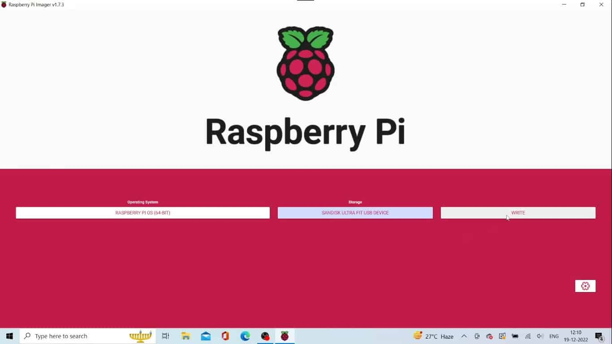

1. **Raspberry Pi OS image is being written to the USB storage**

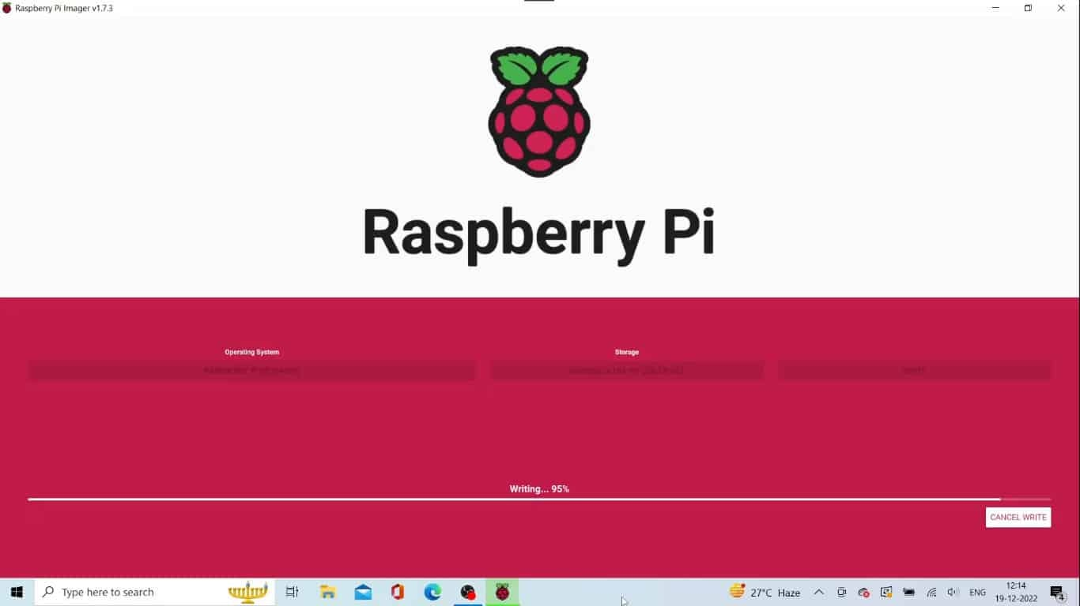

1. **Raspberry Pi OS image is being verified**

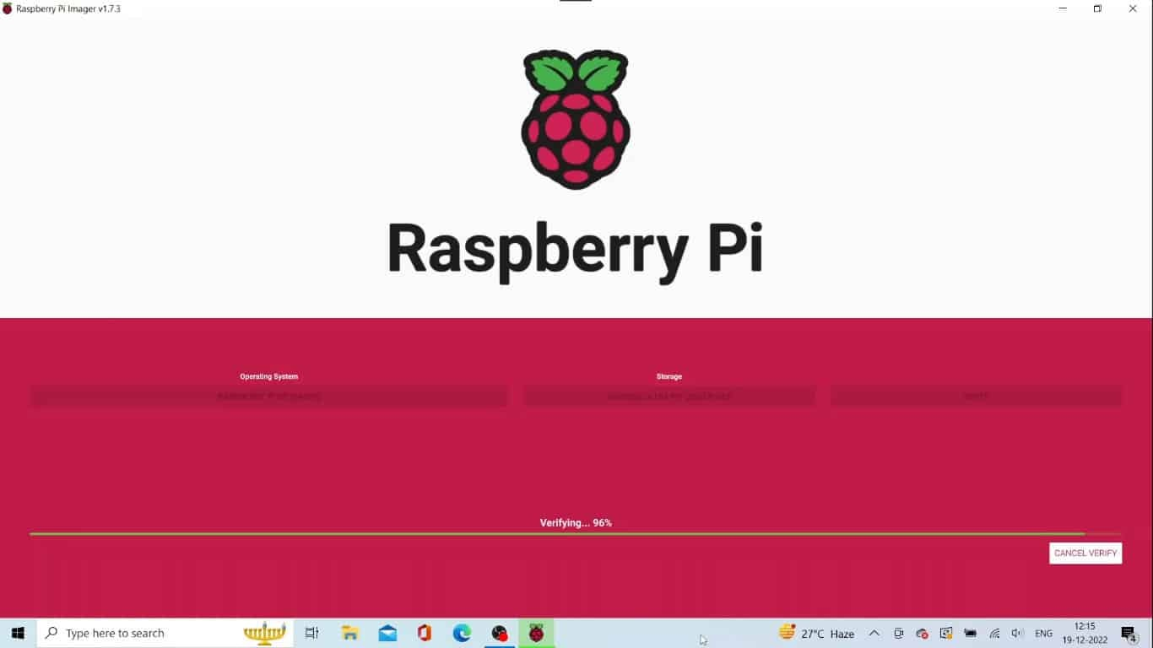

1. **Raspberry Pi OS image is written to the USB storage drive**

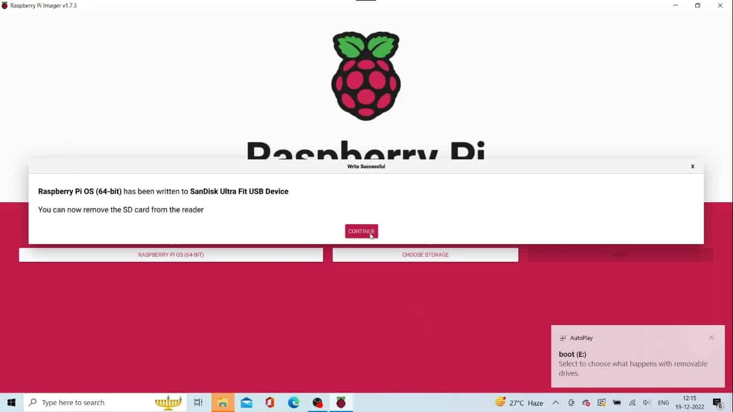

1. **Boot the Raspberry Pi inserting the USB drive**

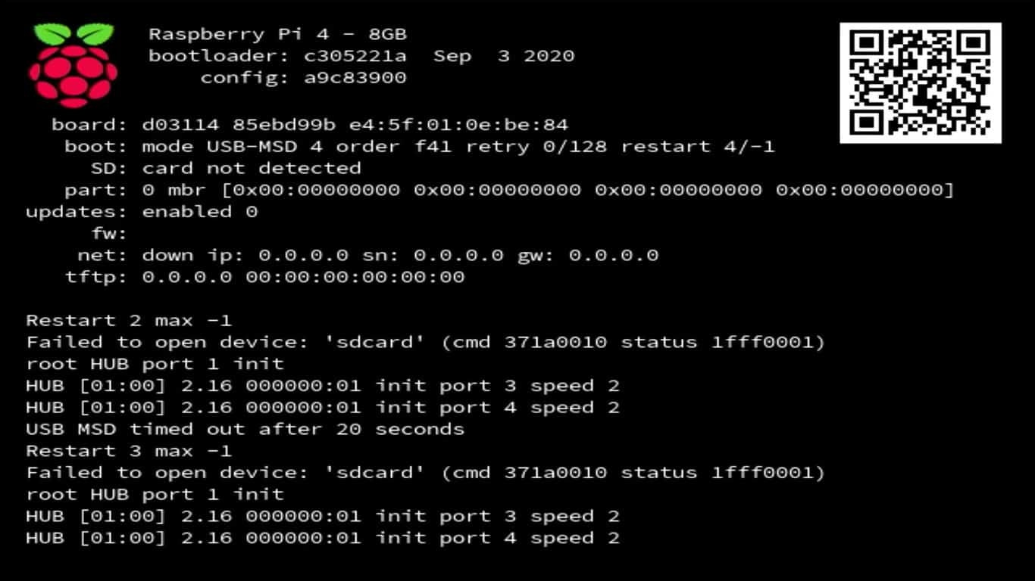

1. **The colored window of Raspberry Pi**

You will see a colored window like shown here. This indicates that your Raspberry Pi passed the POST test and is ready to load the operating system.



1. **Raspberry Pi OS is in the boot process**

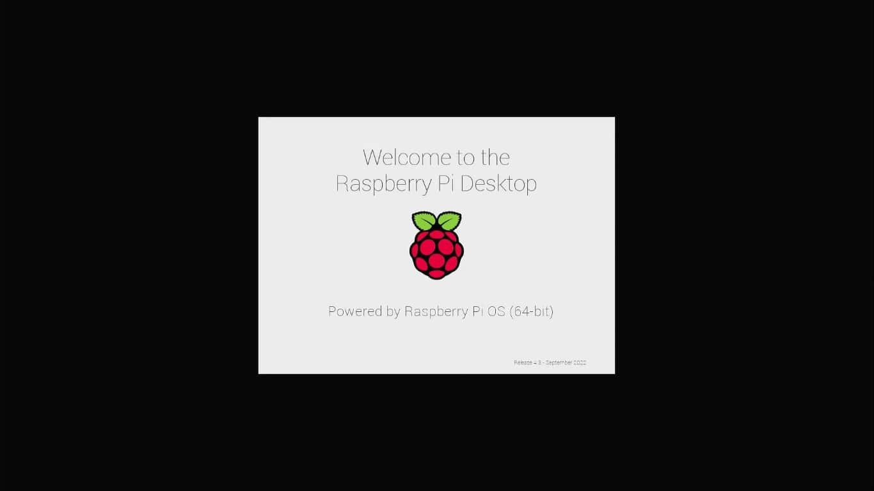

1. **System Configuration Wizard**

Upon the completion of the boot process. **Raspberry Pi OS**will throw a system configuration wizard. **Raspberry Pi OS**will ask for several configurations to be set up.  You should need to Select the preferred settings to configure.  
The configuration wizard starts from the Language selection all the way it goes to the keyboard, network, time zone, and login user account settings.

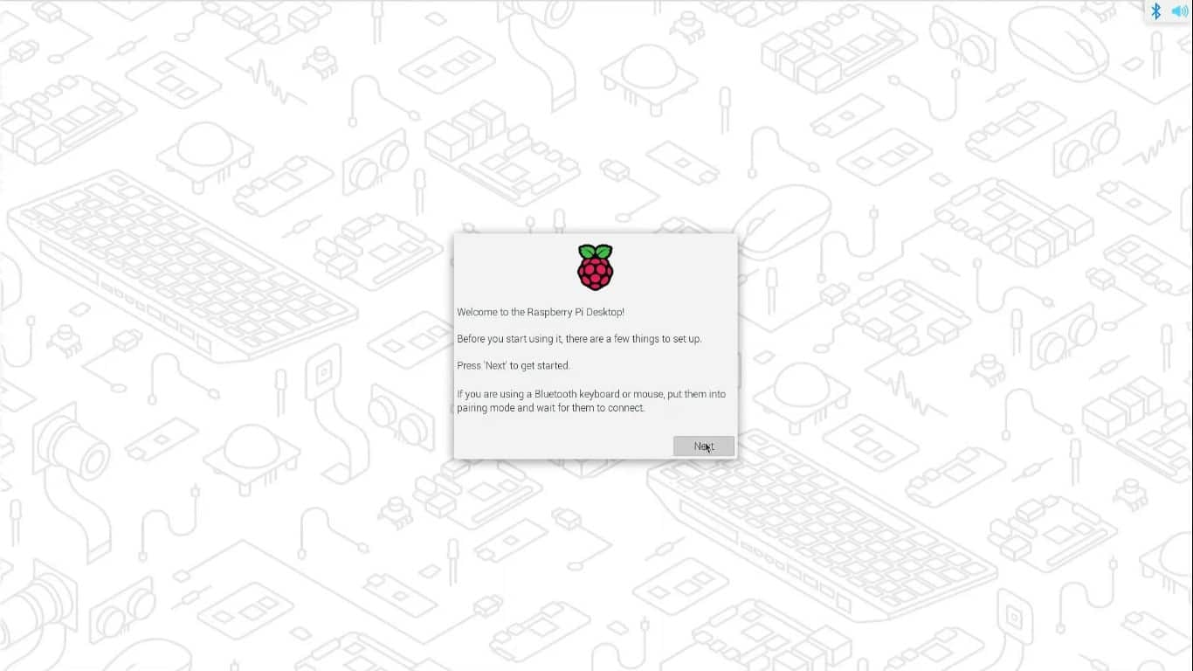

1. **Reboot the Raspberry Pi**

Upon the completion of the set up process, system will ask to reboot to complete the process. Click on the Reboot button to continue Reboot.

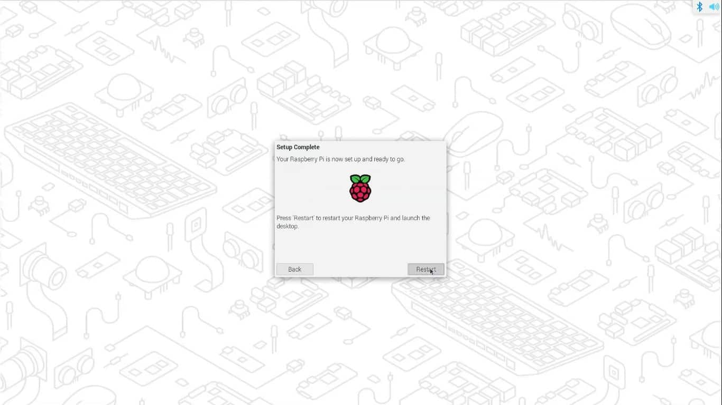

1. **Raspberry Pi OS is running on the Raspberry Pi**

That’s it. Immaterially, upon login, you will be greeted with this desktop screen.

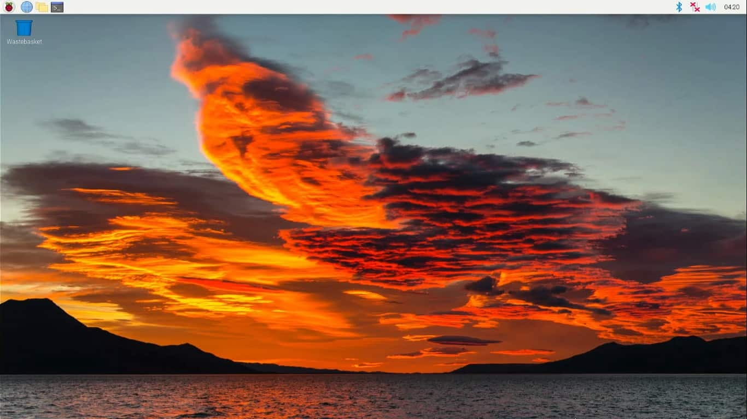

That’s it. Easy isn’t it? This is how you should install Raspberry Pi OS on Raspberry Pi. Now let’s see method 2.

### Method 2: Download the image of Raspberry Pi OS and write it to the micro SD card or the USB drive

1. The first step is to download the latest version of Raspberry Pi OS from the official [website](https://www.raspberrypi.com/software/operating-systems/). Once the download is complete, you can use an application such as [Etcher](https://etcherofficial.com/)to write the image to the microSD card or USB drive.
2. Once the image is written to the microSD card or USB drive, you can insert it into the Raspberry Pi 4 and connect the power supply, mouse, keyboard, and monitor. Once the [Raspberry Pi](https://thesecmaster.com/how-set-up-a-raspberry-pi-for-the-first-time/) 4 has booted up, you will be prompted to log in.
3. Next, you need to configure the language, keyboard, network, time zone, and login user account. To do this, follow the on-screen instructions.
4. You are all set to use pocket size, portable, powerful, and fully functional desktop computer.

## Raspberry Pi OS Post-Installation Steps

Once your Raspberry Pi has rebooted, you should be able to log into Raspberry Pi OS. There are a few post-installation steps you should take to get the most out of your Raspberry Pi.

1. The first step is to make sure that all of your drivers and software are up to date. To do this, you’ll need to open the Software Center and check for updates or open the terminal and issue **sudo apt update && sudo apt upgrade** command.
2. The next step is to install any additional software or applications you may need. You can do this by searching for the software in the Software Center.
3. Finally, you should make sure that your Raspberry Pi is secure. To do this, you’ll need to change the default password, enable the SSH login, and set up a firewall.